USP Water Classifications for the Tissue Bank Industry

As a processor of cell- and tissue-based products, consider the critical supplies required for your process and business to operate. Processing of cell- and tissue-based products require significant volumes of water as water is widely used in the debridement, rinsing, sonication and/or lavage of the tissue throughout its processing. As such a critical supply, anyone involved in the production of these products should be aware of the quality of the water and how that water could potentially impact your products. Do you know what type of water you are using in your process?
Water can be more complicated than many people think. United States Pharmacopeia (USP) <1231>¹ describes several types of water and their preparation, uses and quality attributes. Regardless of whether its bulk water (typically produced on site where they are used), or packaged water (produced, packaged, and sterilized to preserve microbial quality throughout their packaged shelf life), the types are then determined by the testing performed. We put together the following table to help you wade through the complex topic of water. The table below details the types of water and the associated testing requirements to claim a particular type:
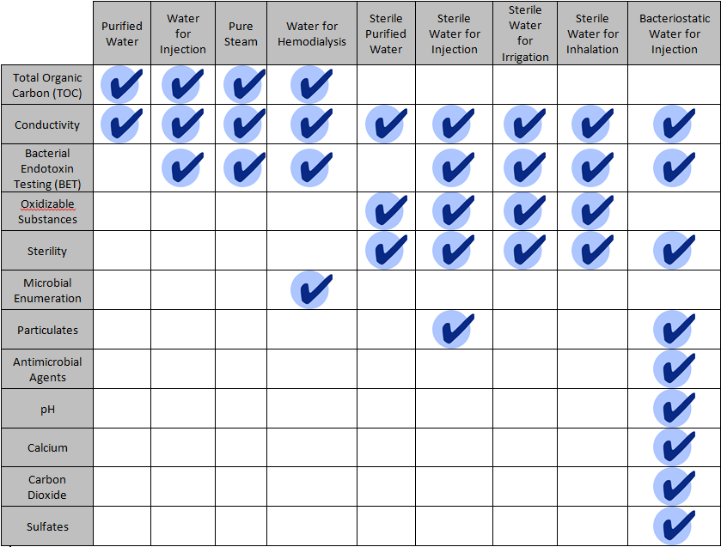

This table provides a quick snapshot of the different types and testing requirements by type, but it doesn’t answer the question about what type of water is appropriate for what usages. For that, we put together the following summaries to help address that question:
Purified Water –
Purified Water is commonly used as a diluent in the production of non-sterile products intended for administration by injection, infusion or implantation, cleaning equipment, and cleaning non-sterile product-contact components. Purified water systems must be validated to consistently produce and distribute water of acceptable chemical and microbiological quality. Systems may be susceptible to biofilms, other undesirable levels of viable microorganisms, or endotoxins. These systems require frequent sanitization and monitoring to ensure appropriate quality at the points of use.

Water for Injection –
Water for Injection is commonly used as an excipient in the production of sterile products and other preparations where product endotoxin content must be controlled, in pharmaceutical applications, such as cleaning of certain equipment and sterile product-contact components. Water for Injection must meet all of the chemical requirements for Purified Water, as well as an additional bacterial endotoxin specification, since endotoxins are produced by the kinds of microorganisms that are prone to inhabit water. Water for Injection systems must be validated to reliably and consistently produce and distribute this quality of water.

Pure Steam –
Pure Steam is commonly used where the steam or its condensate would directly contact products or product contacting surfaces, such as during their preparation, sterilization, or cleaning. These Pure Steam applications include, but are not limited to, porous load sterilization processes, product or cleaning solutions heated by direct steam injection, or humidification of processes where steam injection is used to control the humidity inside processing vessels where the product or their in-process forms are exposed. The sources of contaminants could arise from source water droplets, anticorrosion steam additives, or residues from the steam production and distribution system itself.

Water for Hemodialysis –
Water for Hemodialysis is commonly used for hemodialysis applications, primarily the dilution of hemodialysis concentrate solutions. Water for Hemodialysis is typically produced and used on site. This water contains no added antimicrobials and is not intended for injection.

Sterile Purified Water –
Sterile Purified Water is Purified Water, packaged and rendered sterile. This water is commonly used in the preparation of sterile products, or in analytical applications requiring Purified Water where access to a validated system is not practical, where only a small quantity is needed, or where bulk packaged Purified Water is not suitably microbiologically controlled.

Sterile Water for Injection –
Sterile Water for Injection is Water for Injection packaged and rendered sterile. This water is commonly used in the processing of sterile products and in process steps requiring water in the processing of sterile products. It may also be used for other applications where bulk Water for Injection or Purified Water is indicated but where access to a validated water system is either not practical or where only a relatively small quantity is needed. Sterile Water for Injection is packaged in single-dose containers typically not larger than 1L in size.

Sterile Water for Irrigation –
Sterile Water for Irrigation is Water for Injection packaged and sterilized in single-dose containers of larger than 1L in size that allows rapid delivery of its contents. This water may also be used in other applications which do not have particulate matter specifications, where bulk Water for Injection or Purified Water is indicated but where access to a validated water system is not practical, or where somewhat larger quantities than are provided as Sterile Water for Injection are needed.

Sterile Water for Inhalation –
Sterile Water for Inhalation is Water for Injection that is packaged and rendered sterile. This water is typically intended for use in inhalators and in the preparation of inhalation solutions. It carries a less stringent specification for bacterial endotoxins than Sterile Water for Injection and therefore is not suitable for parenteral applications.

Bacteriostatic Water for Injection –
Bacteriostatic Water for Injection is sterile Water for Injection to which one or more suitable antimicrobial preservatives has been added. This water is typically intended to be used as a diluent in the preparation of sterile products, most typically for multi-dose products that require repeated content withdrawals such as liquid pharmaceuticals. It may be packaged in single-dose or multiple-dose containers typically not larger than 30mL.

Hopefully that helps you to understand what type of water is appropriate for what usages, but now we need to answer the question about whether the water you are using has been tested appropriately to be able to claim it’s a specific type. The first step is to ensure that your supplier is providing you with an accurate certificate of analysis (C of A) for each lot purchased. Second, it is helpful to have an understanding of what each of the tests actually test for and what the results mean to you. For that, we put together the following summaries to help address that question:

Total Organic Carbon (TOC) –
Total Organic Carbon (TOC) testing is performed as a means for screening for organic molecules introduced from source water, from purification and distribution system materials, and from biofilm growing in the system.

Conductivity –
Conductivity testing is performed as a measuring the ion-facilitated electron flow through the water. Water molecules dissociate into ions as a function of pH and temperature and result in a very predictable conductivity. Conductivity can be affected by the presence of CO₂ and inorganic dissolved solids such as chloride, nitrate, sulfate, phosphate anions, sodium, magnesium, calcium, iron, and aluminum cations.

Bacterial Endotoxins Testing (BET) –
Bacterial Endotoxins Testing (BET), also referred to as pyrogen testing, is a test that uses Limulus Amebocyte Lysate, a reagent derived from the blood of the horseshoe crab (Limulus polyphemus), to detect the presence of bacterial endotoxin in the water. Bacterial endotoxin is found in the cell wall of gram negative bacteria and causes a fever in mammalian species.

Oxidizable Substances –
Oxidizable Substances readily lose electrons, such as iron, copper, zinc, carbon, hydrogen, and most organic compounds. This testing is performed in place of TOC for particular grades of water, but is a qualitative, not quantitative, test.

Sterility –
Sterility testing is performed on the water to determine the presence or absence of viable microorganisms on products or portions thereof.

Microbial Enumeration –
Microbial Enumeration testing allows quantitative enumeration of mesophilic bacteria and fungi that may grow under aerobic conditions. These tests are designed primarily to determine whether the water complies with an established specification for microbiological quality.

Particulates –
Particulates testing is of particular concern in injections and parenteral infusions consisting of extraneous mobile undissolved particles, other than gas bubbles, unintentionally present in the solutions. Water designated for use in injectable products require this testing to ensure the source water is not adding particulate matter into the final product to be injected into the blood stream.

Antimicrobial Agents –
Antimicrobial Agents testing demonstrates the effectiveness of antimicrobial protection. Antimicrobial preservatives are toxic substances added to non-sterile dosage forms to protect them from microbiological growth or from microorganisms that are introduced inadvertently during or subsequent to the manufacturing process. In the case of sterile articles packaged in multiple-dose containers, antimicrobial preservatives are added to inhibit the growth of microorganisms that may be introduced from repeatedly withdrawing individual doses.

pH –
pH testing evaluates the negative log of the activity of the hydrogen ion in the water.

Calcium, Carbon dioxide, and Sulfates are all qualitative tests to determine the amounts of these minerals in the water.
As you can see water is definitely more complicated them it seems. Ensure you take the time to understand the quality of the water you are using in your process and how that water could impact your products. Increased scrutiny of the regulatory requirements associated with HCT/Ps and biologics are evolving rapidly as new innovative cell- and tissue-based products are emerging. Don't stray from your mission to honor the gift of donation and to improve/enhance the lives of the patients you help by inadvertently using the wrong type of water that could contaminate your products. Ask the questions to ensure you are on the right path and if you need a guide, CHATA Biosystems can help!

